NEW SEMINAR ROOM
CICE EVACUATION PROCEDURES

CICE RESTUARANT AND BAR
ROOM 1 | ROOM 2 | ROOM  5 | ROOM 6
ROOM  11 | ROOM  12 | ROOM  15 | ROOM  16 | ROOM  17 | ROOM  18
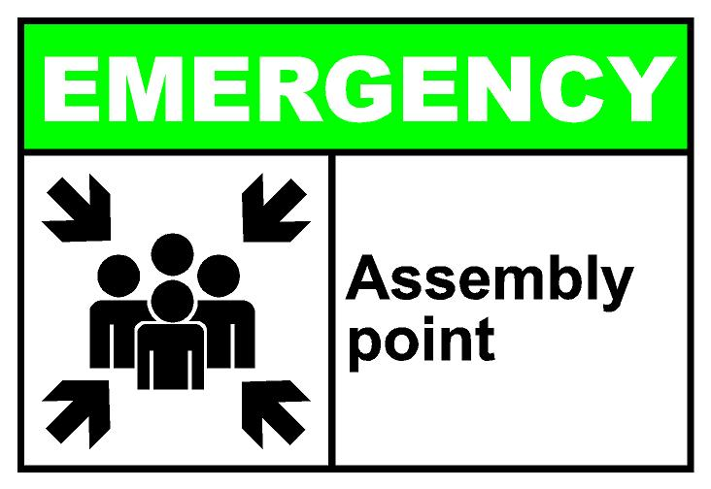
GUEST PARKING
TOILETS 1
EXIT DOOR
e
ROOM  9 | ROOM  10 | ROOM  13 | ROOM  14
LAUNDRY
GATE
GUEST PARKING
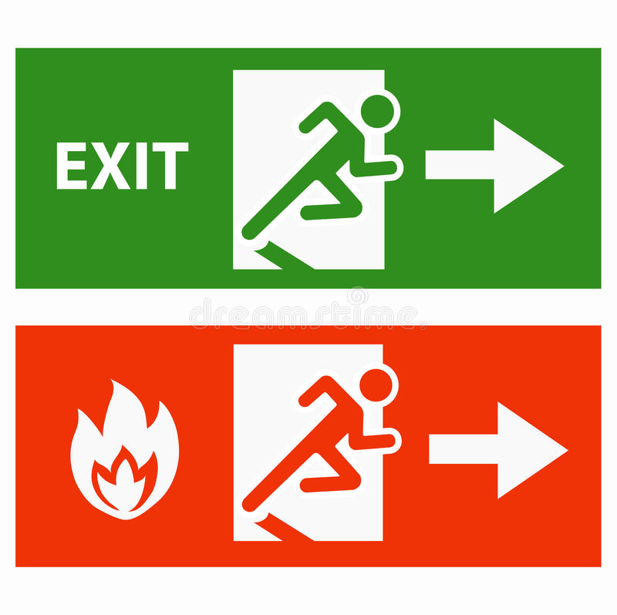

ROOM 3 | ROOM  4 | ROOM  7 | ROOM  8
ROOM  19 | ROOM  20
_{ROOM 21}

ROOM 22
AUDITORIUM
CICE RECEPTION /ADMIN
_{ROOM 23} | _{ROOM}  ₂₄
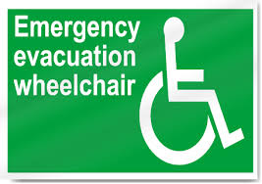
PARKING 1
SEMINAR ROOM 1
Before checking out of the Centre please make sure all your belongings are in order. Thank You

PARKING 2
PARKING 3
Main Gate

EVACUATION PROCEDURE
- Call 998 and report any emergency fire.
- Evacuate the room immediately and close the door.
- Follow the safety route to exit.
- Please do not run but walk to avoid injuries.
- Report immediately to reception for assistance if confused.
- Proceed in an orderly manner to assembly point.
- Remain at assembly point until all- clear is given.
- Do not return to the Centre for friends or luggage.

